3GPP TSG RAN WG1 #125 R1-2603665
Dalian, China, May 18th ~ 22nd, 2026

Source: vivo
Title: Discussion on integration aspects for 6G ISAC
Agenda Item: 10.8.2
Document for: Discussion and Decision
- Introduction
A new study on integrated sensing and communications (ISAC) has been approved in RAN #108 [1],summarized as follows:
Sensing – studies to be based on use cases and associated requirements, as defined in [TR38.914]
- PHY functions and procedures for sensing technology (e.g., waveform. reference signals, measurement feedback, etc…) [RAN1, RAN4]
- Evaluate sensing performance and if necessary, extend channel modelling, for the selected use cases [RAN1]
- Aspects of integration with communication services [RAN1]
- higher layer procedures and protocol aspects [RAN2]
- RAN4 aspects of sensing including RF, coexistence, and testability in coordination with other WGs [RAN4]
Note: RAN1 identify detailed requirements, if triggered by TSG RAN
In RAN1 #124bis [2], the following agreements on aspects for the integration of sensing with communication were made.
Agreement-1
- On RS for ISAC, study at least the following aspects, considering sensing performance, resource overhead and impact to communication
  - RS for communication is reused for sensing
  - Enhanced RS for sensing, taking reuse of RS for communication as starting point
    - Note: Part of or all of the RS may be used for communication purpose, and it does not mean the final decision on whether the enhanced RS is used for communication purpose is to be made in this agenda.
  - Dedicated RS for sensing

Agreement-2
- Study RE patterns of RS for sensing, considering sensing performance, resource overhead and impact to communication
- Note: enhancements on RS sequence if any will be discussed in agenda 10.8.3

Agreement-3
- On measurement for ISAC, study at least the following aspects.
  - Measurement definitions/levels for TRP-side measurement, taking the measurement Levels studied in NR ISAC as starting point
  - Measurement definitions/levels for UE-side measurement
  - Impacts of non-ideal factors on measurement
  - Other aspects are not precluded
  - Note: this discussion may or may not mean there is specification impact

Agreement-4
- On measurement report for ISAC, study at least the following aspects and applicable scenarios (e.g., sensing modes, targets, etc.) from RAN1 perspective.
  - Measurement reporting mechanism from UE
    - Option 1A: The UE measurements and/or assistance information if needed from UE can be directly sent to aNB
    - Option 1B: The UE measurements and/or assistance information if needed from UE can be sent to SF
  - Measurement reporting mechanism from aNB
    - Option 2A: The aNB measurements and/or assistance information if needed from aNB can be directly sent to UE
    - Option 2B: The aNB measurements and/or assistance information if needed from aNB can be sent to SF
  - The study may require cross-WG coordination.
  - Note: combination of multiple options is not precluded.
  - Note: measurements in each option may be different

Agreement-5
- On measurement report for ISAC, study impacts from at least the following aspects from RAN1 perspective
  - Measurement reporting mechanism
    - E.g., Periodic, semi-persistent, aperiodic, event-triggered report as starting point
    - Reporting signaling e.g., L1, L2, higher layer, etc.
  - Other aspects are not precluded
  - The study may require cross-WG coordination.
In this contribution, we present our views on general aspects for integration of sensing with communication, signal design, measurement and report, multi-antenna techniques, non-ideal factors and communication assistance.

- General aspects for integration with communication
In RAN SI Study on 6G Scenarios and Requirements, the following use cases and requirements are agreed for sensing.
The 6GR and 6G RAN architecture shall at least support use cases of
- detection and/or tracking of passive objects, at least including UAVs, human, vehicles and AGVs.,
- communication assistance.
Table 5.1.17-1: Sensing-related requirements
 | Indoor Factory | Urban Macro
Detection Probability | 95% | 95%
False Alarm Probability | 5% | 5%
Horizontal Localization Accuracy | 2 m | 5 m
Vertical Localization Accuracy | N/A | 8 m
Velocity Accuracy | 2 m/s | 4 m/s

The ISAC scenario defined by ITU-R aims to simultaneously provide both communication and sensing services by 6G systems. The key principle is to ensure that the additional comprehensive costs incurred by adding sensing functionalities on the basis of communication capabilities including standardization costs, hardware and software costs for base stations and terminals, network deployment costs, and operation and maintenance costs are kept within a controllable range. This significantly elevates the importance of considering integration with communication for sensing design.
In the evaluation of 5G sensing SI, the detection performance of UAV by multi-TRP sensing is much better than single-TRP sensing under the assumption of 5GA-ISAC study in 3GPP TR 38.765 because multiple TRPs can sense UAV from different directions and obtain multiple sensing results for combination. 6GR will study more sensing modes than 5GA. Combining the sensing results from multi-TRPs/UEs (e.g., fusion of sensing data of UE A to TRP A bistatic sensing and UE B to TRP B bistatic sensing) should be supported by 6GR to improve the sensing performance.
- Combining the sensing results from multi-TRPs/UEs can improve the sensing performance.
- 6GR should support cooperative sensing/multi-static sensing mechanism involving multiple TRPs and/or UEs.
In RAN#111 meeting, the following is agreed for UE positioning.
The 6GR and 6G RAN shall support RAT-dependent and RAT-independent positioning techniques (e.g. ECID and A-GNSS) to satisfy the requirements in section 5.1.14 of TR 38.914 and regulatory location services.
Table 5.1.14-1: Positioning accuracy
Deployment Scenario | Horizontal Accuracy (m)
Indoor Factory | 0.75
Urban Macro | 6

For TRP to UE bistatic and UE to TRP bistatic sensing modes, the location of the UE needs to be determined; otherwise, accurate sensing results such as the position of passive targets cannot be acquired. In addition, the use cases in sensing assisted communication also require UE location information. From the protocol design perspective, given the extensive commonalities between positioning and sensing in signal design, definition of measurement quantities, and reporting mechanisms, the two can be designed in a unified and efficient way.
- RAN1 studies reference signals to support both sensing and UE positioning.
- RAN1 studies the unified design of measurement and report for sensing and UE positioning.

- Sensing signals
  - Design principles for sensing signals
Sensing signals should be designed to satisfy the sensing performance metrics, including at least unambiguous range, unambiguous velocity, range resolution and velocity resolution. Table 1 summarizes the calculation formulae of sensing performance metrics for both monostatic and bistatic sensing.
Table 1: Sensing performance and calculation formulas for monostatic and bistatic sensing.
Sensing Performance metrics | Calculation Formula for Monostatic Sensing | Calculation Formula for Bistatic Sensing
Unambiguous range | $$R_{max}=\frac{c}{2∆F}$$ | $$R_{max}=\frac{c}{2∆Fcos\left(\frac{β}{2}\right)}$$
Unambiguous velocity | $$v_{max}=±\frac{λ}{4∆T}$$ | $$v_{max}=±\frac{λ}{4∆Tcos\left(\frac{β}{2}\right)}$$
Range resolution | $$∆R=\frac{c}{2B }$$ | $$∆R=\frac{c}{2Bcos\left(\frac{β}{2}\right) }$$
Velocity resolution | $$∆v=\frac{λ}{2T_{CPI}}$$ | $$∆v=\frac{λ}{2T_{CPI}cos\left(\frac{β}{2}\right)}$$
In Table 1, $B$ is the bandwidth of sensing signals, $∆F$ is the frequency-domain resource spacing, $∆T$ is the time-domain resource spacing, $T_{CPI}$ is the coherent processing interval, c is the speed of light, λ is the wavelength, and $β$ is the bistatic angle.
According to TR 38.914 [3], the 6G sensing use cases of detecting and/or tracking passive objects, including UAVs, human, automotive vehicles and AGVs are agreed. The characteristics of sensing signals should at least satisfy the unambiguous range, unambiguous velocity and resolution performance requirements for these use cases. Typically, NR bandwidths (e.g., 100 MHz in FR1) can already address the range resolution constraints. Velocity resolution e.g., radial velocity resolution requirements depend on the Coherent Processing Interval (CPI). The CPI also affects the coherent processing gain and the performance of moving target detection. It enables the distinction between moving targets and clutter based on the difference in radial velocity (i.e., Doppler). Therefore, a sufficiently long CPI may be required according to the target velocity to ensure effective clutter suppression.
Furthermore, due to the influence of the bistatic factor cos(β/2) in the unambiguous range and unambiguous velocity formulae, the resulting unambiguous range and unambiguous velocity in bistatic sensing is typically larger than that in monostatic sensing assuming the same signal configuration. For simplicity, the analysis of the unambiguous range and unambiguous velocity performance of monostatic sensing mode assuming a 7GHz carrier frequency and 30 kHz subcarrier spacing is summarized in Table 2. The required signal configurations, including frequency density and time-domain minimum transmission periodicity, are calculated directly based on the unambiguous range and unambiguous velocity requirements. For bandwidth and CPI requirements, typical recommended configurations for different use cases are also provided in Table 2.

Table 2: Performance requirements and required signal configurations for different use cases of monostatic sensing mode.
Scenario | Use case | Maximum unambiguous range (m) | Maximum unambiguous velocity (km/h) | Required signal  configuration
UMa | UAVs | 833 | 180 | - frequency density (REs per RB): 2  - minimum transmission periodicity (slots): 0.5  - bandwidth (MHz): 100, 200, 400  - CPI (slots): 80~640
InH | Human | 130 | 3 | - frequency density (REs per RB): 0.5  - minimum transmission periodicity (slots): 25  - bandwidth (MHz): 100, 200, 400  - CPI (slots): 160~1280
Urban grid | Human | 417 | 3 | - frequency density (REs per RB): 1  - minimum transmission periodicity (slots): 25  - bandwidth (MHz): 100, 200, 400  - CPI (slots): 160~1280
Urban grid | Automotive vehicles | 417 | 60 | - frequency density (REs per RB): 1  - minimum transmission periodicity (slots): 1  - bandwidth (MHz): 100, 200, 400  - CPI (slots): 80~640
InF-SH | AGVs | 335 | 10 | - frequency density (REs per RB): 1  - minimum transmission periodicity (slots): 7  - bandwidth (MHz): 100, 200, 400  - CPI (slots): 160~1280
Note1: Detailed analysis of the sensing coverage requirement, i.e., the unambiguous range requirements, is provided in Annex-1 of Section 10.

Based on the above analysis of signal configuration requirements for different sensing use cases, the following three approaches for sensing reference signal (RS) design are considered, consistent with the agreement made in RAN1 #124bis:
- Approach 1: Reuse of communication RS for sensing.
- Approach 2: Enhanced RS for sensing, taking reuse of communication RS as a starting point.
- Approach 3: Dedicated RS for sensing.
In Approach 1, candidate communication signals such as CSI-RS and SRS can be used as a starting point for the study of sensing services. Since 6G communication signals have not yet been defined, the sensing performance of NR-like signals can be studied and evaluated first to identify whether communication signals are suitable for sensing or can meet sensing requirements. Intuitively, directly reusing of communication signals allows operators to provide basic sensing services without additional signal overhead, especially for use cases that do not require stringent sensing performance. For use cases with stringent sensing requirements, enhancements to communication reference signals as described in Approach 2 may be necessary. If simulation results show that communication reference signals, even with necessary enhancements in Approach 2, still cannot meet the sensing requirements, a new signal design would be needed, i.e., dedicated sensing signal design in Approach 3.
- For sensing reference signal design, study communication reference signals firstly to identify whether they can satisfy the sensing requirements.

In NR systems, CSI-RS is primarily used for downlink channel measurements, beam management, time-frequency tracking, and mobility management. SRS is primarily used for uplink channel sounding, codebook-based and non-codebook-based uplink transmission, beam management, and reciprocity-based downlink precoding. It is expected that these fundamental principles will remain unchanged in 6GR.
For the TRP-UE bistatic mode, similar to communication, CSI-RS and SRS can be prioritized for sensing purposes for downlink and uplink respectively. The following sections provide sensing performance analysis based on NR communication signal configurations for different sensing use cases. For the evaluation in this section, typical CSI-RS and SRS configurations in NR systems are assumed, and the achievable sensing performance is provided in Table 3.
Table 3: Typical CSI-RS and SRS configurations and the relevant sensing performance.
RS configuration | Maximum frequency density (REs per RB) | Maximum unambiguous range (m) | Minimum/typical periodicity (slots) | Maximum unambiguous velocity (km/h)
Single-port CSI-RS | 3 | 1250 | 4/20 | 19.3/3.9
Multi-port CSI-RS | 1 | 417 | 4/20 | 19.3/3.9
SRS | 6 (Comb2) | 3750 | 1/20 | 77.1/3.9

A comparison is made between Table 2 and Table 3. It can be observed that the requirements for most use cases can be satisfied by existing CSI-RS or SRS configurations, whereas the use cases of detection and/or tracking UAVs or automotive vehicles may not be satisfied by NR signals. In particular, the unambiguous velocity requirement of these use cases cannot be satisfied due to the insufficient time-domain density of CSI-RS. Consequently, enhancements to the time-domain configuration of CSI-RS, e.g., configuring multiple CSI-RS resources or supporting a shorter minimum transmission periodicity, may be needed to meet the sensing measurement requirements.
In addition to frequency density and the periodicity, the necessity of multi-port for AoD estimation, anti-interference capability, and resource overhead reduction, as will be illustrated in detail in section 3.2, should also be considered when reusing communication reference signals for sensing.
- CSI-RS and SRS in NR are capable of meeting the unambiguous range for use cases of detecting and/or tracking passive objects as defined in TR 38.914.
- CSI-RS and SRS in NR are capable of meeting velocity requirements of the use cases of detecting and/or tracking human or AGVs.
- CSI-RS in NR cannot meet velocity requirements of the use cases of detecting and/or tracking UAVs or automotive vehicles.
- With time domain configuration enhancements, the CSI-RS can meet the above velocity requirements.
- Prioritize the reuse of communication reference signals (e.g., CSI-RS and SRS) for sensing, with consideration of the following potential requirements: enhanced frequency density and periodicity, necessity of multi-port support for AoD estimation, anti-interference capability, and resource overhead reduction. These requirements should be coordinated with the MIMO agenda to facilitate a unified RS design.
  - Signal design for ISAC

Multi-port signal
According to TR 38.914 [3], the detection and/or tracking of passive objects as well as communication assistance are supported in 6GR. The angle estimation plays a critical role in these use cases. For example, the angle measurements are needed for passive target localization and trajectory tracking in mono-static or bi-static sensing. As shown in Figure 1(a), the location of the sensing target can be derived via simple geometric computations, leveraging angle measurement results from either the aNB or UE side, in combination with the location coordinates of the aNB and UE, as well as multipath delay measurement results between the aNB and UE, e.g., the delay of the LOS path and the NLOS path caused by the sensing target. Another example is environmental reconstruction which is important prerequisite for communication assistance. The environmental reconstruction requires angle measurements for static environment objects sensing, as shown in Figure 1(b). Angle estimations obtained from either the aNB or UE side are applicable to the use cases above. However, the aNB has an inherent advantage in ensuring reliable angle accuracy due to its large array aperture.
In uplink sensing, the angle of arrival (AoA) of multipaths can be estimated by receiving the sensing signal using multiple antenna ports but may suffer from low SNR due to the low transmission power of UE. In downlink sensing, to estimate the angle of departure (AoD) at the aNB side, there are two possible solutions, i.e., the solution based on beam selection and the solution based on multi-port RS. In the first solution, since each beam is associated with a direction, the angle can be estimated based on the beam selected via RSRP. However, this solution is expected to have large estimation error since the angle resolution is limited by the beamwidth of each beam. On the contrary, accurate AoD estimation can be obtained based on multi-port RS via some classical algorithms, such as MUSIC algorithm. Therefore, the multi-port RS is essential for AoD estimation. Furthermore, to avoid introducing extra RS overhead for AoD estimation, multi-port RS for communication, e.g., CSI-RS, should be considered as the starting point for sensing.

Figure 1: Illustration of use case that needs angle estimation. (a) Target localization and trajectory tracking (b) Environmental reconstruction.
- For target localization, trajectory tracking and environmental reconstruction, angle estimation is critical. Angle measurement and estimation at aNB side is feasible due to aNB’s large aperture.
- Multi-port signal should be employed for AoD estimation in downlink sensing.
- Multi-port RS for communication, e.g., CSI-RS, should be considered as the starting point for AoD estimation in 6GR.

Time-domain randomization of reference signals
Communication systems typically perform signal processing per slot with limited consideration for inter-slot or inter-frame sequence correlation. For example, the PN sequence generator for CSI-RS in NR is initialized with the following equation, where the reference signals are generated repeatedly in each radio frame.
$$c_{\text{init}}=\left(2^{10}\left(N_{\text{symb}}^{\text{slot}}n_{\text{s,f}}^{μ}+l+1\right)\left(2n_{\text{ID}}+1\right)+n_{\text{ID}}\right)\text{mod}2^{31}$$
Where $N_{\text{symb}}^{\text{slot}}$ is the number of symbols per slot, $n_{\text{s,f}}^{μ}$ is the slot number within a frame for subcarrier spacing configuration $μ$, $l$ is the OFDM symbol index with in a slot, and $n_{\text{ID}}$equals the higher-layer parameter scramblingID or sequenceGenerationConfig.
If CSI-RS is reused for sensing, both communication and sensing requirements should be considered. Since sensing processing typically involves cross-slot or cross-frame operations, time-domain randomization of reference signals is desirable to enable coherent sensing processing.
The same issue applies to SRS without group/sequence hopping or cyclic shift hopping, where sequence remains the same over time, resulting in high correlation across slots/frames. Even when group/sequence hopping is enabled, the hopping pattern is determined by a PN sequence initialized at the beginning of each radio frame, resulting in pattern repetition every frame. Furthermore, when cyclic shift hopping is enabled, additional impacts require further discussion. For example, the use of cyclic shifts may introduce ambiguity in delay measurement for sensing, which requires further investigation. In summary, time-domain randomization of SRS resources without group/sequence hopping or cyclic shift hopping needs to be considered.
Initial evaluation results comparing the reference signals with and without time-domain randomization are provided. By introducing time-domain scrambling to the CSI-RS, autocorrelation and cross-correlation gains can be observed through performance comparisons between improved reference signals and original reference signals (without time-domain randomization) in Figure 2.
Figure 2: Cross-correlation performance of reference signals after time-domain randomization.
Furthermore, the detected delay-Doppler map at the receiver side, corresponding to the original and improved CSI-RS, are illustrated in Figure 3. Taking the UAV use case as an example, one or more UAVs are deployed in the central sector, and sensing is performed by the TRP associated with that sector. Interference from TRPs corresponding to the adjacent sites is considered, and details of interference modelling can be found in our contribution [6]. As observed in Figure 3, for the original CSI-RS, the echo from the sensing target is buried under interference and becomes indistinguishable, whereas the improved CSI-RS provides significantly better anti‑interference performance.
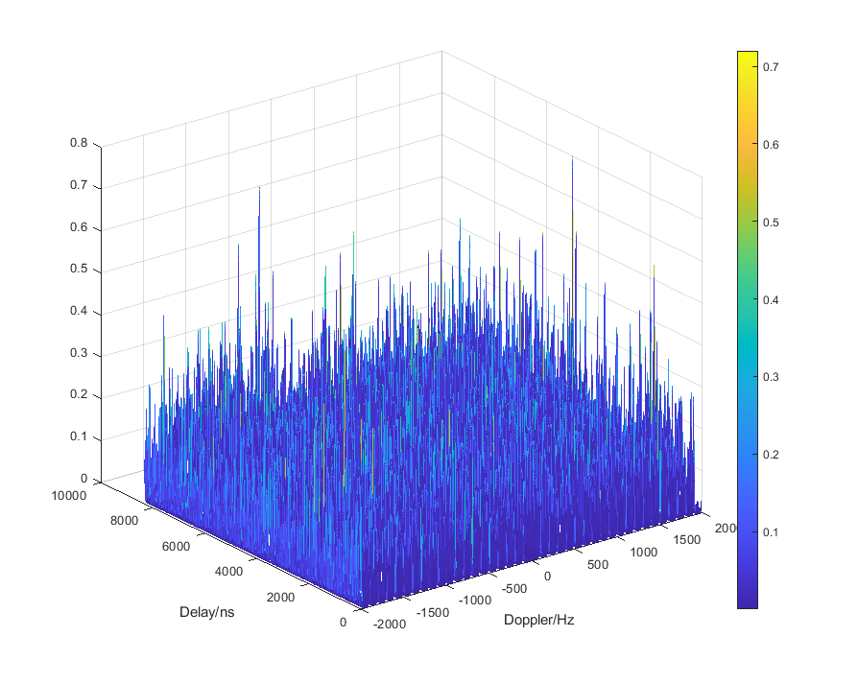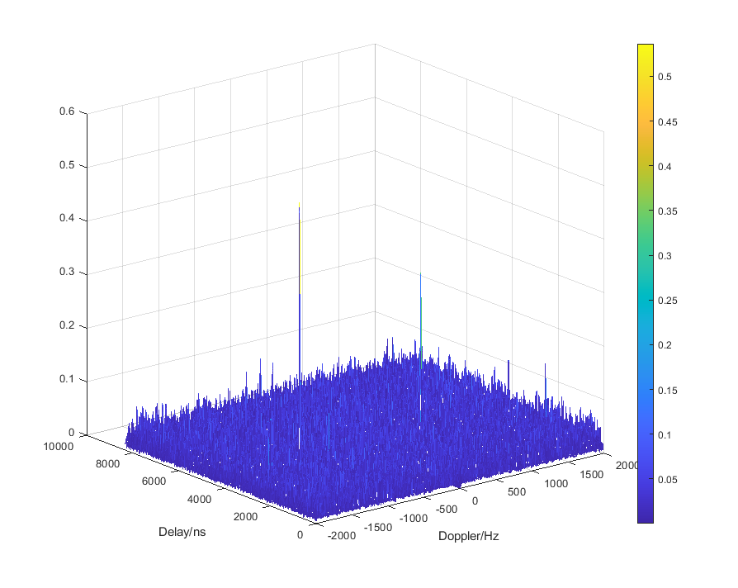
Figure 3: Delay-Doppler map corresponding to the original (left) and improved (right) CSI-RS
- Sensing processing requires cross-slot or cross-frame operations, whereas time-domain randomization of reference signals is desirable to support coherent processing. Moreover, reference signals with time-domain randomisation can provide much better cross-correlation performance and improved anti-interference properties.
- Time-domain randomization of reference signals should be supported to enhance sensing performance, especially when the communication reference signals are reused.

Resource mapping
Following the agreement in the last meeting, the resource element (RE) patterns for sensing reference signals (RS) require further study, taking into account sensing performance, resource overhead, and the impact on communications. In our view, the critical aspect lies in balancing performance and overhead. Specifically, uniformly distributing high-density sensing signals in frequency/time domain is simple and performs well, but at high overhead cost. For example, to satisfy the UAV detection requirements (Section 3.1), time-domain mapping would need sensing signals on 1 OFDM symbol every 7 symbols. Such overhead may be unacceptable in practice.
Furthermore, according to the analyses in Section 3.1, uniform sensing signals in frequency and/or time domain may suffer from some challenges, including:
- Large resource overhead: To meet the resolution requirements, sensing signals typically occupy significant bandwidth in the frequency domain and long durations in the time domain. For instance, to measure typical targets like pedestrians and vehicles, the sensing signal bandwidth needs to be in the range of hundreds of MHz, and the CPI usually spans from tens to hundreds of milliseconds. Furthermore, to satisfy the requirements of maximum unambiguous range of delay and Doppler frequency, a large number of subcarriers and OFDM symbols are required. Consequently, in multi-port scenarios, the number of occupied REs increases linearly with the number of ports, leading to substantial total resource overhead.
- Poor signal configuration flexibility: To achieve high-resolution sensing performance, sensing signals require a wide span of time-frequency resources, and uniform sampling necessitates the occupation of periodic signal resources. In ISAC scenarios, a diverse mix of communication services (including URLLC) coexists with sensing services. Consequently, with various signals and channels dedicated to specific functions, it is difficult to guarantee that signal resources repeating at a specific period can always be allocated to a sensing signal. On the other hand, fully utilizing existing NR reference signals would significantly reduce sensing resource overhead and accelerate the deployment of sensing capabilities. However, since existing NR reference signals are designed based on communication requirements, they are typically non-uniformly distributed over large time spans, thereby preventing the configuration of uniformly sampled sensing signals.
Since sensing targets are typically sparse in the delay and Doppler domains, the signal can be reconstructed from sub-Nyquist samples. Thus, non-uniform signal design can be employed for sensing resource mapping to overcome the limitations of uniform signals and strike a better balance between performance and overhead. Provided that specific design requirements are met, non-uniform signal design can maintain the similar maximum unambiguous range and resolution as uniform signal design, while significantly reducing resource overhead.
- For RE patterns of RS for sensing, RAN1 studies non-uniform resource mapping schemes for sensing signals, so as to reduce resource overhead while maintaining maximum unambiguous range and resolution comparable to those of uniform resource mapping.
To leverage the existing periodic reference signal design to the fullest extent, non-uniform sensing signals can be constructed by combing two or more uniform signal patterns. Figure 4 shows two kinds of non-uniform patterns for sensing signals. The maximum unambiguous range and resolution performance of the two kinds of non-uniform sensing signals are similar to that of the corresponding uniform signal in principles.
Figure 4: Different signal resource mapping schemes.

Frequency hopping of sensing signals
Frequency hopping is studied in 5G for the configurations of PRS, SRS, etc. In the design of sensing signals, the introduction of frequency hopping technology is also promising, due to that frequency hopping technique can help to address the issues of limited bandwidth and sensing coverage induced by the UE hardware.
In ISAC systems employing frequency hopping technology, the RF retuning may introduce phase deviations. These phase deviations primarily stem from the phase discontinuity of the frequency synthesizer during frequency switching, as well as the differential channel responses experienced by signals at different frequency points.
These phase deviations will lead to a failure in the coherent accumulation of frequency-hopping signals. For instance, the delay-Doppler spectrums will be dispersed, leading to severe impacts on signal detection and parameters estimation. Therefore, it is essential to introduce a high-precision phase compensation mechanism to mitigate the phase deviations of the various hops.
To address this issue, an efficient and low-complexity solution is to utilize the overlapping frequency intervals between adjacent frequency hops for phase deviation estimation and correction. The core concept of this method is that although the center frequency of the hopping signal changes, there is a common spectral portion between consecutive hopping slots in the frequency domain. The signal components within these overlapping intervals theoretically possess a deterministic phase relationship.
In practical implementation, the receiver extracts the signals within the overlapping frequency intervals and calculates the cross-correlation function or phase difference between consecutive hops. This allows for the precise estimation of the phase deviations introduced by the frequency hopping. Then, a corresponding phase compensation can be performed. This ensures strict phase consistency when combining frequency-hopping sensing signals, ensuring correct coherent accumulation of all hops.
Considering the difference of sensing signal processing and communication signal processing, the design and related processing procedure of frequency-hopping sensing signal may differ from that of reference signal for communication. Thus, frequency hopping of sensing signals and the corresponding phase compensation mechanism should be studied for 6G ISAC.
- RAN1 studies frequency hopping scheme of sensing signals and the corresponding phase compensation mechanism for frequency-hopped sensing signals, so as to address the phase deviation problem introduced during RF retuning.

- Measurement and report
Agreement:
- On measurement report for ISAC, study at least the following aspects and applicable scenarios (e.g., sensing modes, targets, etc.) from RAN1 perspective.
  - Measurement reporting mechanism from UE
    - Option 1A: The UE measurements and/or assistance information if needed from UE can be directly sent to aNB
    - Option 1B: The UE measurements and/or assistance information if needed from UE can be sent to SF
  - Measurement reporting mechanism from aNB
    - Option 2A: The aNB measurements and/or assistance information if needed from aNB can be directly sent to UE
    - Option 2B: The aNB measurements and/or assistance information if needed from aNB can be sent to SF
  - The study may require cross-WG coordination.
  - Note: combination of multiple options is not precluded.
  - Note: measurements in each option may be different
Agreement:
- On measurement for ISAC, study at least the following aspects.
  - Measurement definitions/levels for TRP-side measurement, taking the measurement Levels studied in NR ISAC as starting point
  - Measurement definitions/levels for UE-side measurement
  - Impacts of non-ideal factors on measurement
  - Other aspects are not precluded
  - Note: this discussion may or may not mean there is specification impact

Firstly, the selection between Option 1A/2A and Option 1B/2B of Measurement reporting mechanism may depend on the specific use case. For example, in object detection and/or tracking scenarios, both UE-side and aNB-side measurements and/or assistance information can be transmitted to the SF. In contrast, for communication assistance, the UE measurements and/or assistance information can be sent directly to the aNB.
- The selection between Option 1A/2A and Option 1B/2B of Measurement reporting mechanism may depend on the specific use case.
  - UE-side measurement
Based on the agreement in the last meeting, taking the measurement Levels studied in NR ISAC as starting point for TRP-side measurement, but there is no reference for UE-side measurement. Therefore, we propose existing sensing measurement for TRP-side measurement can be slightly adapted for UE-side measurement.
- A sensing-measurement procedure originally defined for TRP monostatic in NR can be adapted into a UE-centric framework. The following revised formulation can serve as a starting point for UE-side sensing measurements and reporting for 6G.
Modified Version
From RAN1 perspective, the following measurements that may be reported from RAN are identified in the study of NR ISAC. Note: Down selection of Level(s)/Option(s) for recommendation can be discussed separately.
- Level A: Raw data per Tx antenna port per OFDM symbol per RX antenna port per TRP from a UE for a given time stamp
  - Option A1: Amplitude and phase samples in time/delay domain of the estimated channel, i.e., Amplitude and phase values of channel impulse response
  - Option A2: Amplitude and phase per subcarrier in frequency domain of the estimated channel
- Level B: Amplitude and phase profile of delay, and/or Doppler, and/or angle from a UE for a given time stamp by using window(s) of the [consecutive] samples in delay, Doppler and/or angle domain
  - Option B1: Delay-Doppler profile per Tx antenna port per Rx antenna port, which includes the amplitude and phase samples distributed across different delays and Doppler shifts.
  - Option B2: Delay-Angle profile per Tx antenna port per OFDM symbol, which includes the amplitude and phase samples distributed across different delays and spatial angles (e.g., Angle of Arrival).
  - Option B3: Delay-Doppler-Angle profile per Tx antenna port, which includes the amplitude and phase samples distributed across delay, Doppler, and angle domains.
  - Option B4: Delay profile per Tx antenna port per OFDM symbol per Rx antenna port, which includes the amplitude and phase samples distributed across different delays.
  - Note: Level B is applicable for either LCS or GCS
- Level C: per detected path/point measurements per Tx antenna port per TRP from a UE which may be reflected/scattered from scattering point(s).
  - Option C1: Delay/range, Doppler/velocity, one or multiple 3D angles, and [power/confidence metric] per detected path for a given time stamp.
    - A path is associated with one couple {delay/range, Doppler/velocity, [power/confidence metric]}, and one or multiple 3D angles.
  - Option C2: Doppler/velocity, position, and [power/confidence metric] per detected path for a given time stamp.
    - A path is associated with one doppler/velocity, [power/confidence metric], one or multiple positions
  - Option C3: Delay/range, Doppler/velocity, 3D angle, and [power/confidence metric] per detected path for a given time stamp.
    - A path is associated with one delay, and one or multiple triple {Doppler/velocity, 3D angle, [power/confidence metric]}
  - Option C4: Delay/range, Doppler/velocity, 3D angle, and [power/confidence metric] per detected point for a given time stamp
    - A point is associated with one range/delay, one Doppler/velocity, one 3D angle
  - Option C5: Position, velocity, and [power/confidence metric] per detected point for a given time stamp
    - A point is associated with one position, one velocity
  - FFS: Velocity can be
    - Opt 1: radial velocity
    - Opt 2: 3D velocity
  - Note:
    - Position can be defined in either LCS or GCS
    - Angle can be defined in either LCS or GCS
    - Ambiguity issue will be further discussed
    - 3D angle refers to a pair of horizontal and vertical angles
- Level D: Object/target level measurement from a UE [per TRP or per gNB]
  - One or more value pair(s) {position, velocity} in GCS for a given time stamp is reported for a detected object/target,
    - Option D1: Only one value pair {position, velocity} in GCS for a given time stamp is reported for a detected object/target. The association of multiple measurements across different time stamps for the same detected object/target is not reported.
    - Option D2: Only one value pair {position, velocity} in GCS for a given time stamp is reported for a detected object/target. The association of multiple measurements across different time stamps for the same detected object/target is reported.
    - Option D3: One or more value pairs {position, velocity} in GCS for a given time stamp are reported for a detected object/target. The association of multiple measurements across different time stamps for the same detected object/target is reported.
    - Option D4: One or more value pairs {position, velocity} in GCS for a given time stamp are reported for a detected object/target. The association of multiple measurements across different time stamps for the same detected object/target is not reported.
  - Note: Ambiguity issue can be further discussed if any
  - Note: velocity is 3D velocity for Option D2/D3
  - FFS: velocity can be radial velocity or 3D velocity for Option D1/D4

Measurement reporting mechanism from UE
For specific UE-side measurements, Level A may not be practical due to the larger overhead. In this section, we propose to focus on the analysis of measurements and/or assistance information for Levels B, C, and D at the UE side, and the initial analysis are summarized in the following Table 4.
Table 4: The Measurement information and/or assistance information for UE-side measurement.
Measurement level/option | Measurement information and/or assistance information from UE | Assistance information to UE for the measurement
Option B1/B4 | Measurement: Delay-Doppler profile or Delay profile  Assistance information: UE velocity, and/or UE position | - RS configuration for ISAC  - window(s) and the [consecutive] samples related information
Option B2/B3 | Measurement: Delay-Angle profile or Delay-Doppler-Angle profile  Assistance information: UE velocity at least | - RS configuration for ISAC  - window(s) and the [consecutive] samples related information  - Antenna configuration and/or beam information for angle measurement
Option C1/C3/C4 | Measurement: Delay/range, Doppler/velocity, 3D angle for detected path or point  Assistance information: UE velocity at least | - RS configuration for ISAC  - Antenna configuration and/or beam information for angle measurement
Option C2/C5 | Measurement: Doppler/velocity, position, or, Position, velocity for detected path or point  Assistance information: none | - RS configuration for ISAC  - Antenna configuration and/or beam information for angle measurement  - Location of TRP
Level D | Measurement: One or more value pair(s) {position, velocity} for a detected object/target  Assistance information: none | - RS configuration for ISAC  - Antenna configuration and/or beam information for angle measurement  - Location of TRP

Based on the table above, we observe that the required and reported information varies across different levels of UE-side measurements. More assistance information on the UE side is needed if the UE is expected to calculate angles or detect objects/targets. Otherwise, additional UE-related information, including privacy-sensitive data (e.g., UE location or velocity), needs to be provided to the aNB or SF for NW-side object/target detection.
- TRP location information and/or beam/antenna related information is needed if the UE is expected to calculate angles or detect objects/targets. Otherwise, additional UE-related information, including privacy-sensitive data (e.g., UE location or velocity), needs to be provided to the aNB or SF for NW-side object/target detection.
Moreover, in our view, the angle information (e.g., AoD difference in bistatic plane (e.g., a in the figure) between LOS path and Target path on the TRP side, or AoA difference in bistatic plane (e.g., $β$ in the figure) between LOS path and Target path on the UE side) is important to detection and/or tracking sensing targets/objects. But, considering the limited Rx antenna configuration on the UE side, it is uncertain whether the UE (especially for handheld UE) have the capability to estimate AoA. If not, how the UE report angle-related information in Level B and Level C measurements, e.g., through the Angle of Departure (AoD) or by another method, need further study. From our perspective, the AoD method can be supported by multiple resources measurements (e.g., NR AoD), or multiple port resource measurement (e.g., according to NR DFT basis)
Therefore, we propose
- For UE side measurement, further study the method to obtain the angle of detected path (e.g., AoA or AoD) considering the limitation of the Rx antenna configuration on the UE side, e.g.,
- AoD calculation based on multiple resources measurements and TRP beam/antenna information
- AoD calculation based on multiple port RS measurement
Furthermore, for the /range measurements mentioned above, several options require further study for the potential down selection:
- $d_{total}$ (i.e., the target link path delay/range, $d_{total}$=$d_{aNB-target}+d_{target-UE}$)
- $d_{aNB-target}$ (i.e., the delay/range between TRP and object/target)
- $d_{total}-d_{LoS}$ (i.e., the delay/range difference between target link and LoS link)
- $d_{total-1}-d_{total-2}$ (i.e., the delay/range difference between target-1 link and target-2 link)
Figure 5: Illustration for Delay and angle measurement.

- For the delay/range measurements, study the following options
- $d_{total}$ (i.e., the target link path delay/range, $d_{total}$=$d_{aNB-target}+d_{target-UE}$)
- $d_{aNB-target}$ (i.e., the delay/range between TRP and object/target)
- $d_{total}-d_{LoS}$ (i.e., the delay/range difference between target link and LoS link)
- $d_{total-1}-d_{total-2}$ (i.e., the delay/range difference between target-1 link and target-2 link)
Lastly, from the UE perspective, supporting the reporting of UE-side measurement in a way that protects UE privacy as an optional approach is very important, as it leaves sufficient flexibility for the industry to choose how to implement it. For example, directly report the delay (i.e., the distance between the TRP and the object/target) and the angle of the detected path, or the {position, velocity} of a detected object/target can be considered as candidate option since this information is decoupled from the UE’s own location and only reflects the relationship between the TRP and the object/target.
- Consider UE privacy in the down-selection of UE-side measurement and assistance information reporting.
- For example, candidate options may include directly reporting the delay (i.e., the distance between the TRP and the object/target) and the angle of the detected target path, or reporting the position and velocity of a detected object/target.
  - TRP-side measurement
In the last meeting, the measurement Levels studied in NR ISAC is agreed as starting point for TRP-side measurement. In this section, we focus on the analysis of TRP-side measurements and/or assistance information for Levels A, B, C, and D, and the initial analysis are summarized in the following Table 5.
Table 5: The Measurement information and/or assistance information for TRP-side measurement.
Measurement level/option | Measurement information and/or assistance information from TRP | Assistance information to TRP for the measurement
Option A | Measurement: Raw data  Assistance information:  - Location of TRP  - Step size in delay domain if samples in delay domain is reported  - Time information related to OFDM symbols used for measurement  - Antenna configuration and/or beam information | None
Option B | Measurement: raw data within a window  Assistance information:  - Location of TRP  - LCS to GCS transformation information  - Information related to sampling of delay, doppler and/or angle profile | - window(s) and the [consecutive] samples related information
Option C1/C3/C4 | Measurement: Delay/range, Doppler/velocity, 3D angle for detected path or point  Assistance information:  - Location of TRP  - LCS to GCS transformation information | - None
Option C2/C5 | Measurement: Doppler/velocity, position, or, Position, velocity for detected path or point  Assistance information: none | - Location of UE  - UE velocity
Level D | Measurement: One or more value pair(s) {position, velocity} for a detected object/target  Assistance information: none | - Location of UE  - UE velocity

Similar to the UE-side measurement analysis, more UE assistance information is needed for TRP-side measurement if the TRP is expected to calculate position of detect objects/targets. Otherwise, additional TRP-related information, including TRP location and beam/antenna information, needs to be provided to the SF for SF-side object/target detection.
- UE assistance information (e.g., Location of UE, or UE velocity) is needed if the TRP is expected to calculate position of detect objects/targets. Otherwise, additional TRP-related information, including TRP location and beam/antenna information, needs to be provided to the SF for SF-side object/target detection.

  - Per path SINR
In 5GA, power and confidence metrics for the measurement have been studied as follows. However, what is the metric related to power or confidence metrics remains unclear.
Agreement:
From RAN1 perspective, the metric related to power can be considered for Level C measurement report.
From RAN1 perspective, the metric related to power (if applicable) can be considered for Level D measurement report.
Note: metric related to power may be different from those defined for communication and between Level C and Level D.
From RAN1 perspective, confidence metrics for the measurements can be considered for Level C/D measurement report.
No more discussion on the metric related to power and confidence metrics is expected in the study item from RAN1 study perspective.
In our view, the per path SINR (i.e., the power of detected path relative to the average noise and interference, for example, the power of detected path could be the (average) power of i-th path detected in the delay-Doppler domain, as illustrated in Figure 6) can provide both power metric and confidence metrics information.
Additionally, the per path SINR can provide more accurate path selection or filtration information to help the sensing entity to distinguish the different targets from cluster on different environment (e.g., dense urban environments and open areas).
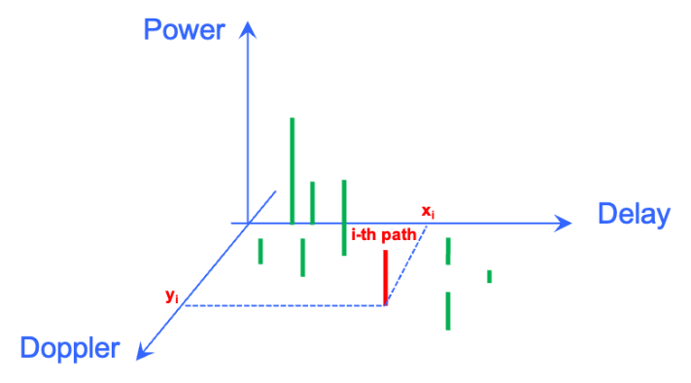
Figure 6: Path(s) defined in delay-Doppler domain.
- Per path SINR can be supported as metric related to power or confidence metrics for the measurements.

  - Micro-Doppler
Sensing targets or their components often exhibit micro-motion such as vibration, rotation, and acceleration. These micro-motions modulate the phase of the echo signal, resulting in corresponding frequency modulation, which is known as the micro-Doppler effect. In 5G studied, there is no enough study and evaluation on micro-Doppler effect. In 6G, detection and/or tracking object includes different type device, e.g., UAVs, human, vehicles, AGVs and background environments, micro-Doppler can provide more information with limited specification impact and processing complexity since doppler had been agreed as one measurement type.
Based on the following evaluation results, we observe that Micro-Doppler modeling significantly enhances object detection and tracking. Specifically, comparing the left and right sub-figures in Figure 7: the left plot (without micro-Doppler modeling) shows no detectable target in the delay-Doppler spectrum after clutter suppression, while the right plot (with micro-Doppler modeling) reveals distinguishable target echoes separated from static clutter due to the characteristic micro-Doppler signature. Therefore, we propose further study the effect of micro-Doppler on sensing performance.
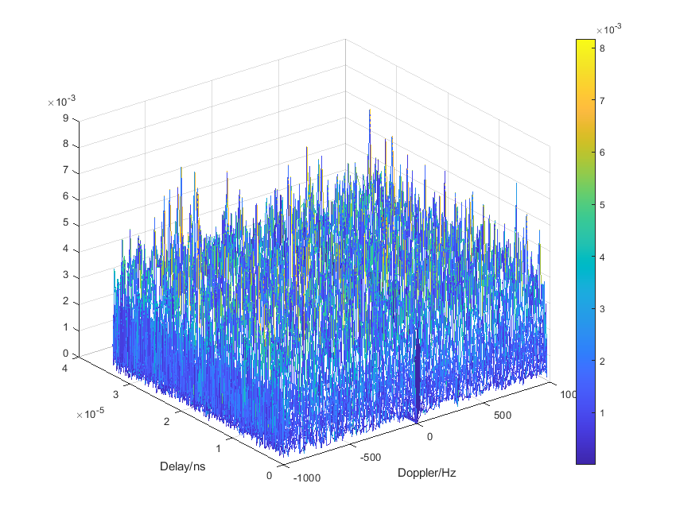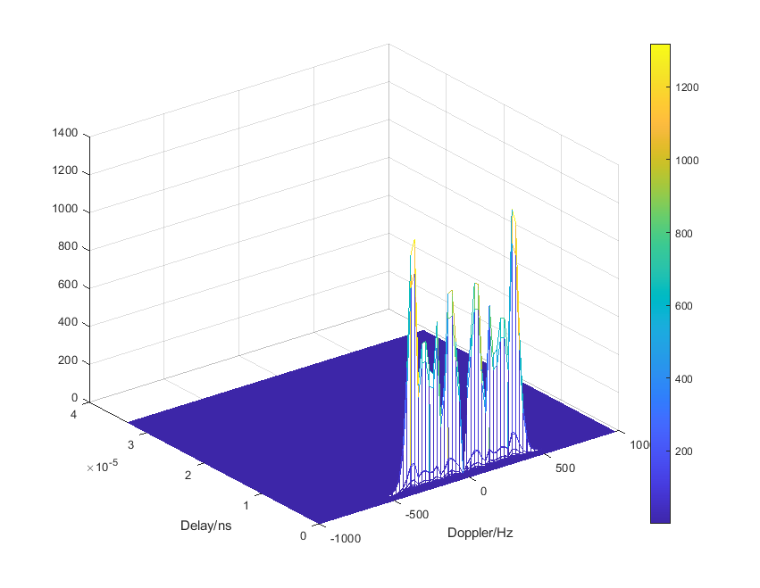
Figure 7: Delay-Doppler spectrum with and without micro-Doppler modeling.
- Study the benefit and necessity of micro-Doppler.
- Further study the effect of micro-Doppler on sensing performance.

  - Measurement reporting
Agreement:
- On measurement report for ISAC, study impacts from at least the following aspects from RAN1 perspective
  - Measurement reporting mechanism
    - E.g., Periodic, semi-persistent, aperiodic, event-triggered report as starting point
    - Reporting signaling e.g., L1, L2, higher layer, etc.
  - Other aspects are not precluded
  - The study may require cross-WG coordination.

For the measurement report, the above agreement has been reached. In our view, higher-layer signaling is preferred for reporting since sensing information reporting does not have stringent latency requirements. And then, once higher layer reporting is sufficient for the service, periodic, and event-triggered report can be considered as measurement reporting mechanisms.
- Sensing measurements can be reported via higher layer signaling.
- Periodic, and event-triggered report can be considered as measurement reporting mechanisms
Firstly, the selection between Option 1A/2A and Option 1B/2B of Measurement reporting in agreement-4 in introduction section mechanism may depend on the specific use case. For example, in object detection and/or tracking scenarios, both UE-side and aNB-side measurements and/or assistance information can be transmitted to the SF. In contrast, for communication assistance, the UE measurements and/or assistance information can be sent directly to the aNB.
- The selection between Option 1A/2A and Option 1B/2B of Measurement reporting mechanism may depend on the specific use case.
  - Non-ideal factors and solutions
In RAN1 #124b, it was agreed to study the impacts of non-ideal factors on measurement for ISAC. For UE-involved sensing modes, including the TRP-UE bi-static sensing and UE-TRP bi-static sensing, non-ideal factors should be elaborately considered, otherwise no correct sensing result could be obtained.
For UE-involved sensing, the non-ideal factors considered here primarily stem from time-frequency asynchrony between the sensing transmitter and receiver, as well as the imperfect hardware characteristics of UE, including:
- Timing Offset (TO): The transmitter and receiver generate clock signals using their respective clock sources for timing synchronization. The discrepancy between these clock signals results in a timing offset, which introduces an additional phase shift in the frequency domain beyond that caused by signal propagation delay. Consequently, TO creates ambiguity in sensing signal delay estimation.
- Timing Drift (TD): The sampling frequency offset between the TRP and the UE would induce timing drift at the receiver side. To overcome the timing drift, timing adjustment is designed in communication system to maintain the clock synchronization between the TRP and the UE. This causes different OFDM symbols to experience varying timing offsets. The TD is defined as the variation component of timing offset over time[7]. Impacts of the TD includes two aspects: misalignment of the delay spectrum in the delay dimension among different OFDM symbols within a CPI, and the phase drift among different OFDM symbols within a CPI. These two aspects of impacts ultimately break the coherency and phase continuity among symbols within a CPI, and lead to the delay-Doppler dispersion.
- Carrier Frequency Offset (CFO): The transmitter and receiver use independent LO sources for signal generation, leading to frequency differences. CFO results in ambiguity in Doppler measurement.
- Random phase: A CPI usually spans more than tens of milliseconds, which generally includes uplink and downlink switching. The unlink and downlink switching would induce random phase, which breaks the coherency and phase continuity among symbols within a CPI, and also lead to the delay-Doppler dispersion.
Among the non-ideal factors mentioned above, the TO and the CFO cause the delay-Doppler spectrum shifts along the delay and Doppler dimensions, respectively, which will not affect the performance of signal detection. In other words, the TO and the CFO would not lead to the increasing of false alarm probability and the decreasing of detection probability.
In contrast, the TD and the random phase would lead to the dispersion of the delay-Doppler spectrum, which severely degrades signal detection performance. To demonstrate the influence of the TD, Figure 8 shows the delay spectrum and delay-Doppler spectrum impacted by non-ideal factors in a prototype test. Figure 8(a) shows the misalignment of the delay spectrum in the delay dimension among OFDM symbols within a CPI, which is induced by the TD (including the timing adjustment). For clearer presentation, oversampling IDFT is adopted to calculate the delay spectrum. The obliquely upward variation shows the influence of the sampling frequency offset between the TRP and the UE, and the jumping change correspond to the timing adjustment. As a result, the delay-Doppler spectrum in Figure 8(b) suffers from severe dispersion, and the sensing target is overwhelmed by dispersion.
Figure 8: Delay spectrum and delay-Doppler spectrum impacted by non-ideal factors.
Figure 9 demonstrates the phase drift induced by the TD. In the prototype test, no uplink and downlink switching occurs within a CPI, thus no random phase exists. Hence, the total phase difference across OFDM symbols shown in Figure 9(a) includes the phase difference induced by the CFO and the phase drift caused by the TD. After the CFO been removed, the phase drift caused by the TD is shown in Figure 9(b).
Figure 9: Phase difference across OFDM symbols within a CPI.
- Among the four kinds of non-ideal factors, the TO and the CFO exert no influence on the signal detection, and the TD and the random phase exert influence on the signal detection.
As to the solutions to overcome the non-ideal factors, algorithm implementations and protocol specifications are needed. On the one hand, the TD, the CFO and the random phase can be mitigated through algorithm implementations, at least for the case of static UE and low-speed moving UE. As an example, the misaligned delay spectrum and the dispersed delay-Doppler spectrum shown in Figure 9 can be recovered through algorithm and then respectively converted to the correct delay spectrum and delay-Doppler spectrum shown in Figure 10.
Figure 10: Delay spectrum and delay-Doppler spectrum after non-ideal factors mitigation.
On the other hand, mitigation of the TO raises requirements for protocol specifications, due to that the TO cannot be mitigated solely through algorithm implementations. For the TO mitigation, mainly two types of methods that are well justified in practical systems: the first relies on the LOS path, and the second requires round-trip measurement based on two-way signal transmission and reception (the most typical one is the round-trip time (RTT) method). For the LOS path method, some prior information would be needed, e.g., TRP/UE location. For the round-trip measurement, configurations, measurement and reporting related to the two-way sensing signal should be specified in the protocols.
- The mitigation of the TD, the CFO and the random phase can be mitigated through algorithm implementations, while the TO mitigation raises requirements for protocol specifications.
Different from the case of NR positioning, impacted by the TD (including the timing adjustment) within a CPI, the round-trip measurement and the corresponding reporting mechanism, should be elaborately designed in 6G ISAC. Besides, round-trip measurement in the NLOS condition should also be studied, enabling the sensing measurement to be applicable in more scenarios.
- RAN1 studies the mechanism of round-trip measurement considering the influence of the TD within a CPI and also the NLOS condition.

- Sensing Beam management
Hybrid beamforming (HBF) is an important and attractive deployment solution at BS side in the FR3 band. Additionally，ISAC is also expected to be deployed in the FR2 band, where analog beamforming is the typical architecture. As a result, beam management is anticipated to be a critical functionality in 6GR. Although there exists beam management for communication in NR, the enhancement is needed to accommodate the characteristics of sensing.
For example, the RSRP served as the primary reporting quantity for beam selection in communication. For TRP-UE bistatic sensing, in channels dominated by a strong Line-of-Sight (LOS) component, the selected beam based on RSRP will be aligned with the LOS path. However, sensing targets are often associated with NLOS paths, which are not aligned with the selected beam. Consequently, beams selected via RSRP are typically suboptimal for sensing, necessitating the study of dedicated sensing-centric reporting metrics for sensing beam management.
- Beams selected via RSRP are typically not aligned with sensing target, and thus suboptimal for sensing.
- RAN1 studies sensing-centric beam management, e.g., sensing-centric reporting quantity.

- Sensing assisted communication
  - Overview of sensing assisted communication
Communication assistance should be supported for sensing by 6GR and 6G RAN architecture[3]. Sensing assisted communication, more precisely, should be sensing related information assisted communication.
Wireless communication environments include both static objects (e.g., buildings, terrain) and dynamic objects (e.g., pedestrians, vehicles), leading to wireless channels containing both time-invariant and time-variant components. For measurements of time-invariant components, the real-time requirement is low and long measurement period is permissible. In contrast, measurements of time-variant components demand a high real-time requirement, since dynamic environmental features are easily transient and hard to predict.
Figure 11: Schematic diagram of sensing related information classification and potential sensing assisted communication use cases.
From the perspective of real-time requirements for information acquisition, sensing related information can be divided into two main categories:
- The first category is offline-measured information, derived from historical measurements. Through data processing techniques including statistical analysis, denoising, filtering, compression, and so on, the time-variant components in the environment are stripped away, and only information about the time-invariant components of the environment is retained.
- The second category is online-measured information, which relies on real-time, on-demand measurements. It can capture information about both time-invariant and time-variant components in the environment simultaneously.
From the perspective of information content, sensing related information can be further classified into the following three types:
- Type I: Information represented in the form of channel parameters. This information includes large-scale channel parameters, i.e., channel gain, path loss, shadow fading, penetration loss, delay spread, angular spread, Rician K-factor, and correlation coefficients of the aforementioned large-scale parameters, etc. This information can also include small-scale parameters, i.e., power, complex amplitude, delay, angles (azimuth/elevation angles in BS and/or UE side) of multipaths, etc. It should be noticed that this type of sensing related information reflects the channel's long-term characteristics and thus belongs to the offline-measured information.
- Type II: Information represented in the form of environment object (EO) parameters. This information includes a set of scattering points or a point cloud of the EO(s). Or equivalently, it contains the EO-related parameters, such as EO’s positions/dimensions/area/thickness, or surface information of EOs (number of reflector surfaces, positions of the surfaces, dimensions of each surface, normal directions of the surfaces, etc.), the electromagnetic parameters of the EOs (permittivity, permeability, conductivity, etc.), and the material parameters of EOs (material type, density, etc.). This type of sensing related information describes static EOs and it also belongs to the offline-measured information.
- Type III: Information represented in the form of sensing measurements. This information includes the sensing results from the sensing entity (i.e., aNB and UE). Specifically, it includes but not limited to raw data from the estimated channel (i.e., amplitude and phase of the channel impulse response or frequency channel response), amplitude and phase profile of delay, and/or Doppler, and/or angle, detected path/point measurements (i.e., delay/range, Doppler/radial velocity, 3D angle, metric related to power, and confidence metric per detected path/point for given time stamps), and object/target level measurements (i.e., position, 3D velocity, metric related to power (if applicable), confidence metric). While this type of sensing related information exhibits partial content overlap with Type I sensing related information, it is derived from online sensing measurements, capable of capturing the time-variant components of the current channel and being leveraged for communication assistance, thus falling into the category of online-measured information.
It should be noted that all the types of the above sensing related information can be TRP specific and UE-position-specific. The large-scale channel parameters of Type I sensing related information can be the statistical results of measurements collected at different UE positions within the cell coverage area. For example, in case that the sensing related information is Type I and TRP and UE-position-specific, such sensing related information is commonly known as channel knowledge map (CKM). For example, for Type II sensing related information, it can also be referred to as environment reconstruction information or digital twin (DT) of environment. There is relevant 6G use case defined by 3GPP SA1, i.e., Section 7.6-- Use case on environment object reconstruction [5]. EOs include stationary objects such as buildings for outdoor scenario, walls and ceilings for indoor scenario. For Type III sensing related information, the definition of sensing measurements in [4] can serve as a foundational starting point for subsequent investigations.
In our opinion, Type I and Type II sensing related information fall into the first category of information, i.e., pre-processed offline-measured information, which is suitable for storage at the CN or aNB side. Notably, compressed sensing related information with a small storage footprint is not excluded for storage at the UE side. Type III sensing related information is categorized as the second category, i.e., online-measured information, which can be measured and obtained in real time on demand by the UE or aNB. Evidently, the acquired Type III sensing related information can be converted into Type I and Type II sensing related information, serving as supplements or updates to the latter, as long as its time-invariant components can be identified. Furthermore, Type II sensing related information can be transformed into Type I sensing related information through electromagnetic computation methods, such as ray tracing.
There are a variety of potential use cases for sensing assisted communication, such as sensing assisted beam management, sensing assisted handover and cell reselection, sensing assisted channel prediction, sensing assisted DMRS channel estimation, and so on. The use cases mentioned above are expected to achieve better performance compared to the counterparts without sensing assistance. Figure 11 shows the schematic diagram of sensing related information classification and potential sensing assisted communication use cases.
Sensing related information acquisition requires measurements from multiple locations within a region, especially for Type I and Type II sensing related information. Sensing performed only by TRPs (e.g., TRP mono-static and TRP-TRP bistatic sensing) can only obtain information at limited positions; therefore, UE-involved sensing (UE-TRP bistatic and TRP-UE bistatic) is needed to acquire information at more locations.
Regarding the utilization of sensing related information, given variations in computing capabilities of communication entities, differences in sensing related information transmission overhead, and diverse communication use cases, the sensing related information employed may differ accordingly. That is, at least one type among Type I, II, and III sensing related information can be adopted. Notably, considering dynamic environmental changes, UE positioning errors, and other factors, usage of Type III sensing related information combined with Type I or Type II sensing related information can be studied.

- There are a variety of potential use cases for sensing assisted communication, such as sensing assisted beam management, sensing assisted handover and cell reselection, sensing assisted channel prediction, sensing assisted DMRS channel estimation, and so on.
- The sensing related information can be classified into following three types: Type I (i.e., information represented in the form of channel parameters), Type II (i.e., information represented in the form of environment object parameters), and Type III (i.e., information represented in the form of sensing measurements).
- RAN1 identifies the schemes of each proposed communication use case including the required sensing related information and how the sensing related information is utilized to improve communication performance. For each communication use case, RAN1 evaluates its communication performance gain, the sensing related information transmission overhead, and computational complexity required.
If sensing related information (e.g., Type I and/or Type II) is stored in the CN, the aNBs and/or UEs performing sensing assisted communication processes need to obtain the corresponding sensing related information from the CN. If sensing related information is stored in the aNB, in addition to directly utilizing this information by aNB, the aNB may also need to send the sensing related information to serving UEs. Alternatively, UEs can assist the aNB in conducting sensing related information measurements (e.g., Type III sensing related information), reporting or updating the information for communication assistance. If some sensing related information is stored in the UE, in addition to directly utilizing this information by UE, the UE may also need to report this information to aNB.
  - Use case 1: sensing assisted beam management
In this section, we provide detailed analysis and initial evaluation results for sensing assisted beam management and sensing assisted channel prediction, specifically utilizing Type III sensing related information mentioned above.

Mechanism for sensing assisted beam management
In advanced beam management schemes (e.g., Rel-18/19 sparse beam sweeping), UE measures a subset of beams (Set B) to predict the optimal beam in the full set (Set A) to reduce measurement overhead. However, relying solely on single-modal scalar measurements (i.e., pure RSRP) has fundamental limitations. In complex multipath environments, UEs at different physical locations may measure similarly RSRP values across the sparse beam subset. As a result, the same RSRP measurements can point to completely different optimal beams. Even with AI/ML-based beam prediction, the performance is bottlenecked by the lack of spatial context. To overcome this issue, Type III sensing related information (online sensing measurements) can be introduced. Specifically, sensing measurements such as per-path AoA/ZoA or AoD/ZoD provides the missing spatial context. By fusing these directional features with the sparse RSRP measurements, the system can effectively distinguish between these confusing locations, thereby improving the beam prediction accuracy.
- Pure RSRP measurements cannot reliably identify the optimal beam because UEs at different locations may have similar or even identical RSRPs. Introducing sensing related information (e.g., AoA/ZoA or AoD/ZoD) provides spatial context to help distinguish these overlapping RSRP features.
The overall implementation procedure of the sensing assisted beam prediction is given in Figure 12.
Figure 12：Implementation procedure of the sensing assisted beam prediction

Preliminary results of sensing assisted beam management
To validate the performance gain of communication assistance, simulation results for sensing assisted beam management were provided in this subsection. Simulation assumptions are given in Table 6.
Table 6：Simulation assumptions for sensing assisted beam management
Parameters | Values
Scenarios | Urban grid with 250m ISD
Operating Frequency | FR2, 30GHz
Tx Beam Configurations | 4 measured beams (set B) to predict 32 beams (set A)
Channel model | ISAC channel with EO Type-II
Sensing related information required | Type III sensing related information: Per path AoA/ZoA, AoD/ZoD
Evaluation metrics | Top 1 Beam prediction accuracy
The evaluation metrics, Top-1 beam prediction accuracy is defined as the ratio of the number of samples where the predicted optimal beam exactly matches the genie-aided best beam to the total number of evaluated samples. To evaluate the performance, the following four schemes are simulated and compared:
- Scheme 1: Non-AI based beam prediction as baseline (Pure RSRP): The optimal beam is selected with the highest RSRP directly from the measured sparse beam subset, without using any AI/ML tools.
- Scheme 2: AI-based prediction beam prediction (Pure RSRP): AI/ML model is utilized to predict the optimal beam in set A, using only the RSRP measurements from set B as input for AI model.
- Scheme 3-1and 3-2: Sensing assisted AI based beam prediction
  - Scheme 3-1: RSRP + AoD/ZoD: Using AI/ML model to predicts the optimal beam by fusing the measured RSRPs with spatial/angular sensing results, specifically the Angle of Departure (AoD) and Zenith angle of Departure (ZoD) of the EO path.
  - Scheme 3-2: RSRP + AoA/ZoA: Using AI/ML model to predicts the optimal beam by fusing the measured RSRPs with spatial/angular sensing results, specifically the Angle of Arrival (AoA) and Zenith angle of Arrival (ZoA) of the EO path.
The corresponding simulation results of sensing assisted beam management are summarised in the following table.
Table 7:Simulation results of sensing assisted beam management
Prediction Scheme Index | Top-1 Beam Prediction Accuracy
Scheme 1 | 31.08%
Scheme 2 | 83.22%
Scheme 3-1 | 88.95%
Scheme 3-2 | 97.32%
As shown in Table 7, utilizing sensing related information (AoA/ZoA or AoD/ZoD) for AI based beam prediction can significantly improves the Top-1 beam prediction accuracy (88.95% for Scheme 3-1 and 97.32% for Scheme 3-2), while achieving 87.5% beam measurement overhead reduction (4 measured beams to predict 32 beams).
- Sensing assisted beam management utilizing Type III sensing related information (AoA/ZoA or AoD/ZoD) can achieve up to 97.32% Top-1 beam prediction accuracy with an 87.5% measurement overhead reduction, outperforming pure RSRP-based schemes.
  - Use case 2: sensing assisted channel prediction

Mechanism for sensing assisted channel prediction
The issue of channel aging has attracted widespread attention in the wireless communication industry, and channel prediction is considered as an effective means to address this issue. Channel prediction can obtain more accurate CSI, reduce pilot overhead, and enhance spectral and energy efficiency.
Channel prediction can be achieved through non-AI-based or AI-based methods, and sensing related information, e.g., online sensing measurement results, is expected to be utilized by both of these methods. For non-AI-based methods, sensing related information can be directly used for channel extrapolation, or used for parameter estimation based on the signal model to reduce the estimation complexity. For AI-based methods, the sensing related information can be the input for AI models, for enhancing the accuracy of the models and/or reducing their complexity.
In sensing assisted channel prediction, the sensing targets are the dominant multipaths in the wireless channel, which are caused by the major scatterers in the environment. When the UE is moving, different multipaths have different Dopplers, which leads to the Doppler spread of the channel. The sensing resources are configured to occupy a certain amount of bandwidth and time width, enabling the sensing entities to utilize these resources to achieve precise measurement at the multipath level. Compared to traditional channel estimation that relies solely on the current pilot symbols for each instance, sensing assisted methods comprehensively utilize multiple pilot symbols over time. This enables the capture of the channel's fine-grained dynamic characteristics, allows for accurate tracking of multipath components, and thereby predicts the future evolution trends, achieving accurate channel prediction.
Referring to the existing channel model in 3GPP TR 38.901 [8], the channel is modeled as a superposition of a set of discrete multipaths. Each path (cluster) contains a certain number of sub-paths, and within each path, the sub-paths have the same or similar delays but different angles and different Doppler frequencies. The channel response between the u-th receiver element and the s-th transmitter element can be represented as follow (see Section 7.5 in [8]),
where
is the complex amplitude of the m-th sub-path in the n-th path, and
is the complex amplitude of the m-th sub-path in the n-th path between the u-th receiver element and the s-th transmitter element. is the Doppler frequency of the m-th sub-path in the n-th path. is the delay of the n-th path.is the power of the m-th sub-path in the n-th path. The definitions of the other parameters in the aforementioned equations are the same as those in 3GPP TR 38.901 [8].
With the help of sensing, the complex amplitude or per receiver and transmitter element pair, the Doppler , the delay , the AoD , the ZoD , the AoA , and the ZoA of the sub-paths of the channel can be estimated. Assuming that these parameters of multipaths remain approximately unchanged within a certain period of time (e.g., several tens or several hundreds of milliseconds), the channel at a future time can be easily predicted as follows
This sensing assisted channel prediction is referred to as parametric model-based prediction. It fully leverages the sensing related information and is expected to effectively combating channel aging and mitigating the resulting degradation in communication transmission performance.
- Traditional channel estimation cannot deal with the problem of channel aging, resulting in a decline in transmission performance. Introducing sensing related information (e.g., sensing-measured complex amplitude, Doppler, delay, AoA, ZoA, AoD, ZoD of the dominant multipaths) can provide accurate tracking and prediction of the channel, and thus resolve this problem.
    - Evaluation method for sensing assisted channel prediction
Figure 13: Illustration of resources in time domain for the proposed scheme and the baseline scheme
For initial investigation, we apply the parametric model-based prediction scheme, which considers multipath parameters of the fading channel remain constant during a period longer than the coherent processing interval (CPI). The sensing related information, especially the measured Dopplers of the dominant multipaths, can be used in channel extrapolation based on the parametric model. Conventional channel estimation is employed in the baseline scheme, and no channel extrapolation is used. Figure 13 illustrates of resources in time domain for the proposed scheme (sensing-assisted channel prediction) and the baseline scheme (without sensing assistance).
Figure 14: Illustration of timing relationship of sensing assisted channel prediction
Squared generalized cosine similarity (SGCS) can be used as the evaluation metrics/KPIs that related to communication. In the evaluation, the true channel is the output of the channel model defined in 3GPP TR 38.901. Assuming ideal channel estimation, the channel estimates match the true channel at the symbol positions where pilots are located.
In the proposed scheme, based on the multipath parameters obtained through sensing including the complex amplitude, Doppler, delay, AoD, ZoD, AoA, ZoA, the channel at any future moment in the prediction window can be predicted. Figure 14 illustrates the timing relationship of sensing assisted channel prediction. In the baseline scheme, the channel estimate is updated with the latest pilot symbol. Before the next pilot arrives, the true channel continues to change (i.e., channel aging occurs), leading to a mismatch between the latest channel estimate and the true channel. It should be noted that within the prediction window, the baseline scheme can still utilize reference signal resources for channel estimation.
For evaluation of the baseline scheme, SGCS between the latest channel estimation and the true channel for each time instant within the prediction window is calculated. For evaluation of the proposed scheme, SGCS between the predicted channel and the true channel for each time instant within the prediction window is calculated. Finally, we can obtain and compare the average SGCS over the prediction window for both the baseline scheme and the proposed scheme.
If the SGCS of the proposed scheme is not inferior to, or even better than, that of the baseline scheme, it indicates that sensing can assist to deal with channel aging effectively. Meanwhile, with the help of sensing assisted channel prediction, reference signal overhead can be effectively reduced. All of these can result in higher throughput or spectrum efficiency.
Based on the above analysis and evaluation results, we have the following proposal:
- RAN1 studies sensing assisted beam management and sensing assisted channel prediction.
- Power control for UE-TRP bistatic sensing
In RAN1 #124bis meeting, many companies propose to study UL power control for UE-TRP bistatic sensing. In the same meeting, it’s agreed to study communication RS, enhanced communication RS, and dedicated RS for sensing. Firstly, it should be clarified whether NR uplink power control for communication (e.g., power control for SRS) is enough for sensing or not. For communication, UL power control is used to compensate for the overall pathloss of all the links between BS and UE. For sensing, however, the power control needs to compensate for the path loss of the STX-target-SRX link. The path loss of the STX-target-SRX link at least depends on the RCS of the sensing target. The RCS of target may be quite small and the received power of STX-target-SRX link may be much smaller than the overall received power. Therefore, the power control method for communication may be not suitable for sensing. For sensing, one possible approach is that UE need to measure the DL RS to obtain the path loss of the STX-target-SRX link and determine the UL power according to open loop power control mechanism.
We think a new or enhanced control mechanism for sensing is necessary. RAN1 should first study and design the RS for sensing. After that, RAN1 can study and design the power control mechanism for sensing. The potential impact to communication caused by new or enhanced control mechanism for sensing needs to be studied at least for the case that communication RS is reused for sensing.
- UL power control for communication compensates for the overall pathloss of all the links between BS and UE, whereas the power control for sensing will compensate for the path loss of the STX-target-SRX link. The path loss of the STX-target-SRX link at least depends on the RCS of the sensing target. The RCS of target may be quite small and the received power of STX-target-SRX link may be much smaller than the overall received power. Therefore, the power control method for communication is not suitable for sensing.
- RAN1 studies uplink power control mechanism for sensing and its impact for communication.

- Conclusions
In this contribution, we made the following observations and proposals:
- Combining the sensing results from multi-TRPs/UEs can improve the sensing performance.
- CSI-RS and SRS in NR are capable of meeting the unambiguous range for use cases of detecting and/or tracking passive objects as defined in TR 38.914.
- CSI-RS and SRS in NR are capable of meeting velocity requirements of the use cases of detecting and/or tracking human or AGVs.
- CSI-RS in NR cannot meet velocity requirements of the use cases of detecting and/or tracking UAVs or automotive vehicles.
- With time domain configuration enhancements, the CSI-RS can meet the above velocity requirements.
- For target localization, trajectory tracking and environmental reconstruction, angle estimation is critical. Angle measurement and estimation at aNB side is feasible due to aNB’s large aperture.
- Multi-port signal should be employed for AoD estimation in downlink sensing.
- Sensing processing requires cross-slot or cross-frame operations, whereas time-domain randomization of reference signals is desirable to support coherent processing. Moreover, reference signals with time-domain randomisation can provide much better cross-correlation performance and improved anti-interference properties.
- Among the four kinds of non-ideal factors, the TO and the CFO exert no influence on the signal detection, and the TD and the random phase exert influence on the signal detection.
- The mitigation of the TD, the CFO and the random phase can be mitigated through algorithm implementations, while the TO mitigation raises requirements for protocol specifications.
- Beams selected via RSRP are typically not aligned with sensing target, and thus suboptimal for sensing.
- There are a variety of potential use cases for sensing assisted communication, such as sensing-aided assisted beam management, sensing assisted handover and cell reselection, sensing assisted channel prediction, sensing assisted DMRS channel estimation, and so on.
- Pure RSRP measurements cannot reliably identify the optimal beam because UEs at different locations may have similar or even identical RSRPs. Introducing sensing related information (e.g., AoA/ZoA or AoD/ZoD) provides spatial context to help distinguish these overlapping RSRP features.
- Sensing assisted beam management utilizing Type III sensing related information (AoA/ZoA or AoD/ZoD) can achieve up to 97.32% Top-1 beam prediction accuracy with an 87.5% measurement overhead reduction, outperforming pure RSRP-based schemes.
- Traditional channel estimation cannot solve the problem of channel aging, resulting in a decline in transmission performance. Introducing sensing related information (e.g., sensing-measured complex amplitude, Doppler, delay, AoA, ZoA, AoD, ZoD of the dominant multipaths) can provide accurate tracking and prediction of the channel, and thus resolve this problem.

- 6GR should support cooperative sensing/multi-static sensing mechanism involving multiple TRPs and/or UEs.
- RAN1 studies reference signals to support both sensing and UE positioning.
- RAN1 studies the unified design of measurement and report for sensing and UE positioning.
- For sensing reference signal design, study communication reference signals firstly to identify whether they can satisfy the sensing requirements.
- Prioritize the reuse of communication reference signals (e.g., CSI-RS and SRS) for sensing, with consideration of the following potential requirements: enhanced frequency density and periodicity, necessity of multi-port support for AoD estimation, anti-interference capability, and resource overhead reduction. These requirements should be coordinated with the MIMO agenda to facilitate a unified RS design.
- Multi-port RS for communication, e.g., CSI-RS, should be considered as the starting point for AoD estimation in 6GR.
- Time-domain randomization of reference signals should be supported to enhance sensing performance, especially when the communication reference signals are reused.
- For RE patterns of RS for sensing, RAN1 studies non-uniform resource mapping schemes for sensing signals, so as to reduce resource overhead while maintaining maximum unambiguous range and resolution comparable to those of uniform resource mapping.
- RAN1 studies frequency hopping scheme of sensing signals and the corresponding phase compensation mechanism for frequency-hopped sensing signals, so as to address the phase deviation problem introduced during RF retuning.
- The selection between Option 1A/2A and Option 1B/2B of Measurement reporting mechanism may depend on the specific use case.
- A sensing-measurement procedure originally defined for TRP monostatic in NR can be adapted into a UE-centric framework. The following revised formulation can serve as a starting point for UE-side sensing measurements and reporting for 6G.
- TRP location information and/or beam/antenna related information is needed if the UE is expected to calculate angles or detect objects/targets. Otherwise, additional UE-related information, including privacy-sensitive data (e.g., UE location or velocity), needs to be provided to the aNB or SF for NW-side object/target detection.
- For UE side measurement, further study the method to obtain the angle of detected path (e.g., AoA or AoD) considering the limitation of the Rx antenna configuration on the UE side, e.g.,
- AoD calculation based on multiple resources measurements and TRP beam/antenna information
- AoD calculation based on multiple port RS measurement
- For the delay/range measurements, study the following options
- $d_{total}$ (i.e., the target link path delay/range, $d_{total}$=$d_{aNB-target}+d_{target-UE}$)
- $d_{aNB-target}$ (i.e., the delay/range between TRP and object/target)
- $d_{total}-d_{LoS}$ (i.e., the delay/range difference between target link and LoS link)
- $d_{total-1}-d_{total-2}$ (i.e., the delay/range difference between target-1 link and target-2 link)
- Consider UE privacy in the down-selection of UE-side measurement and assistance information reporting.
- For example, candidate options may include directly reporting the delay (i.e., the distance between the TRP and the object/target) and the angle of the detected target path, or reporting the position and velocity of a detected object/target.
- UE assistance information (e.g., Location of UE, or UE velocity) is needed if the TRP is expected to calculate position of detect objects/targets. Otherwise, additional TRP-related information, including TRP location and beam/antenna information, needs to be provided to the SF for SF-side object/target detection.
- Per path SINR can be supported as metric related to power or confidence metrics for the measurements.
- Study the benefit and necessity of micro-Doppler.
- Further study the effect of micro-Doppler on sensing performance.
- Sensing measurements can be reported via higher layer signaling.
- Periodic, and event-triggered report can be considered as measurement reporting mechanisms
- The selection between Option 1A/2A and Option 1B/2B of Measurement reporting mechanism may depend on the specific use case.
- RAN1 studies the mechanism of round-trip measurement considering the influence of the TD within a CPI and also the NLOS condition.
- RAN1 studies sensing-centric beam management, e.g., sensing-centric reporting quantity.
- The sensing related information can be classified into following three types: Type I (i.e., information represented in the form of channel parameters), Type II (i.e., information represented in the form of environment object parameters), and Type III (i.e., information represented in the form of sensing measurements).
- RAN1 identifies the schemes of each proposed communication use case including the required sensing related information and how the sensing related information is utilized to improve communication performance. For each communication use case, RAN1 evaluates its communication performance gain, the sensing related information transmission overhead, and computational complexity required.
- RAN1 studies sensing assisted beam management and sensing assisted channel prediction.
- RAN1 studies uplink power control mechanism for sensing and its impact for communication.

- References
- RAN#108, New SID: Study on 6G Radio, RP-251881.
- RAN WG1 Meeting #124bis, Chairman Notes, Malta, April 13th – 17th, 2026.
- 3GPP TR 38.914: “Study on 6G Scenarios and Requirements”, v0.4.0.
- 3GPP TR 38.765: “Study on Integrated Sensing and Communication (ISAC) for NR”, v1.0.0.
- 3GPP TR 22.870, Study on 6G Use Cases and Service Requirements, V1.1.0 (2026-01).
- RAN1#124bis, Discussion on performance evaluations for 6G ISAC, R1-2602031, vivo.
- Shengli Ding, Baolong Chen, Dajie Jiang, Junjie Tan, Yannan Yuan, Jianzhi Li, Jian Yao, Fei Qin, Daqing Zhang, and Chih-Lin I, “Bi-Static ISAC With Asynchronous Transceivers: Mechanism, Solution and Field Test,” IEEE Internet of Things Journal, vol. 12, no. 17, pp. 35923-35940, 01 Sep. 2025.
- 3GPP TR 38.901, “Study on channel model for frequencies from 0.5 to 100 GHz”, V19.2.0 (2025-12).

- Annex
  - A-1 Sensing coverage analysis for different scenarios
For the UMa scenario, as illustrated in Figure 15, the sensing area of interest comprises the three central sectors (marked in red). Considering both geographical location and TRP coverage performance, the TRPs associated with the central sectors, together with the 3 TRPs associated with the adjacent sectors (marked in green), are selected to provide optimal coverage of the target area. Consequently, the required maximum coverage distance for the participating TRPs is represented by the double-headed dashed arrows. And the required maximum sensing distance is calculated as follows:
For an Inter-Site Distance (ISD) of 500m, the maximum coverage requirement is approximately 833m.
For an ISD of 250m, the maximum coverage requirement is approximately 417m.
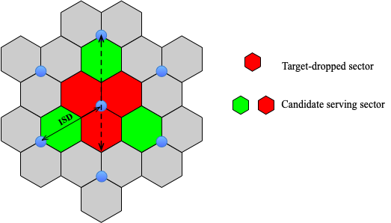
Figure 15: Illustration of sensing coverage requirement for Uma.
Regarding the Urban grid scenario, it is noted that the target dropping area is inherently constrained by the street layout, which distinguishes it from the uniform distribution assumed in the UMa scenario. However, to maintain consistency in sensing performance evaluation, the maximum coverage requirement for the Urban grid can be aligned with the UMa. And the required maximum coverage distance for the participating TRPs is represented by the double-headed dashed arrows, as illustrated in Figure 16. Consequently, for an urban grid deployment with an ISD of 250m, the required maximum sensing coverage distance is approximately 417m.
Figure 16: Illustration of sensing coverage requirement for Urban grid.
For the InF-SH scenario, the room size is defined as 300m*150m with an ISD of 50m. In this evaluation, it is assumed that sensing targets are dropped uniformly throughout the entire topology. Therefore, the requirement for the TRP sensing coverage distance is determined by the maximum distance across the layout, which corresponds to the room diagonal. Based on the layout shown in Figure 17, the required maximum coverage for the InF-SH scenario is approximately 335m.
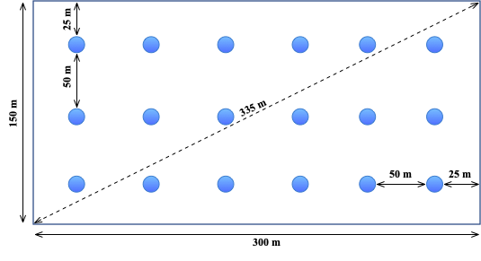
Figure 17: Illustration of sensing coverage requirement for InF-SH.
For the InH scenario, the room size is defined as 120m*50m with an ISD of 20m. It is assumed that sensing targets are dropped uniformly throughout the entire topology. Therefore, the requirement for the TRP sensing coverage is determined by the maximum distance across the layout, which corresponds to the room diagonal. Based on the layout shown in Figure 18, the required maximum coverage for the InH scenario is approximately 130m.
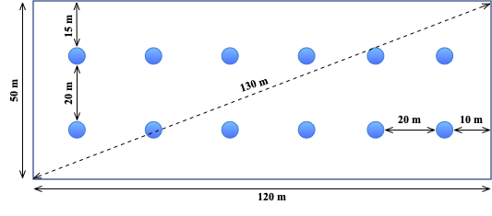
Figure 18: Illustration of sensing coverage requirement for InH.

